Fred Gaily

1-1-4 to 1-1-6 (no song)
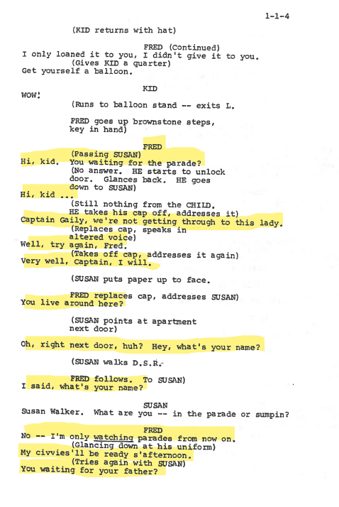
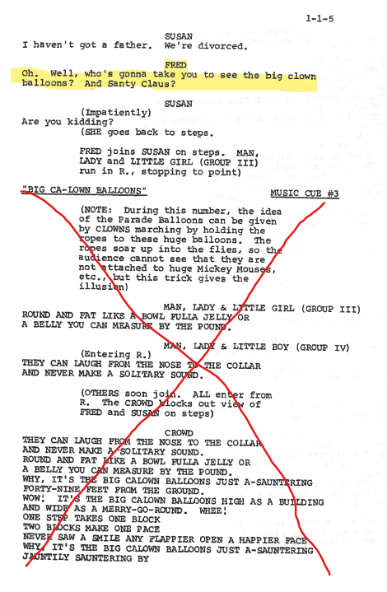
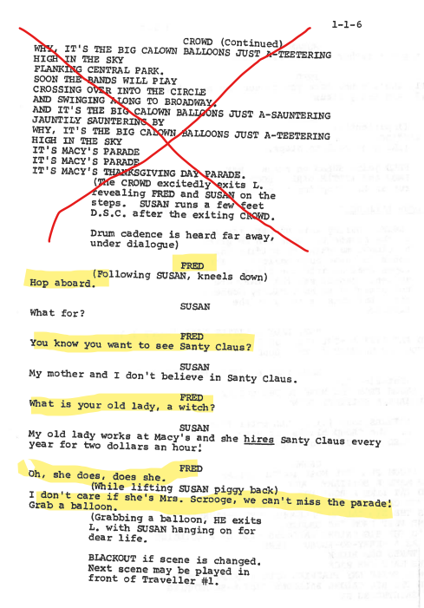
1-13-56 to 1-13-59
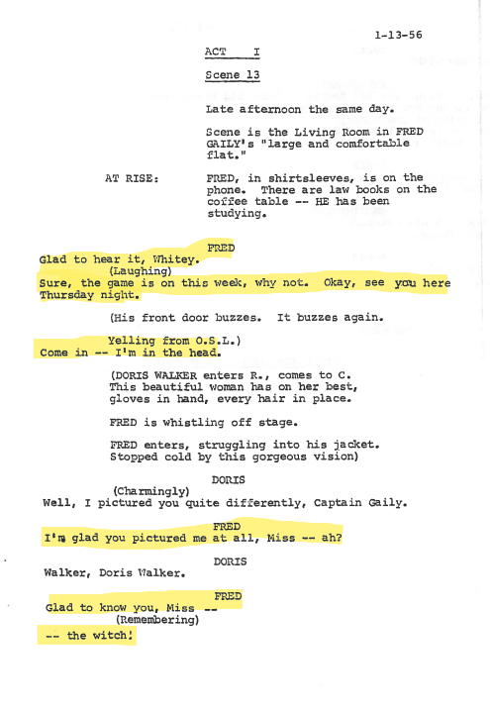
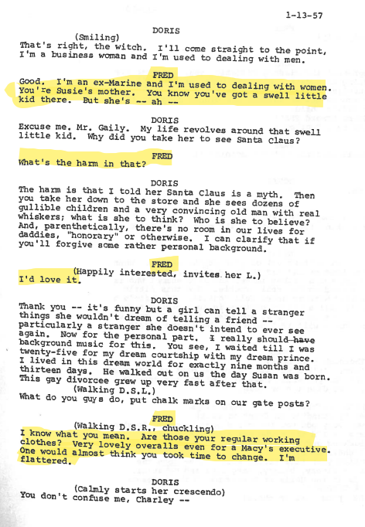
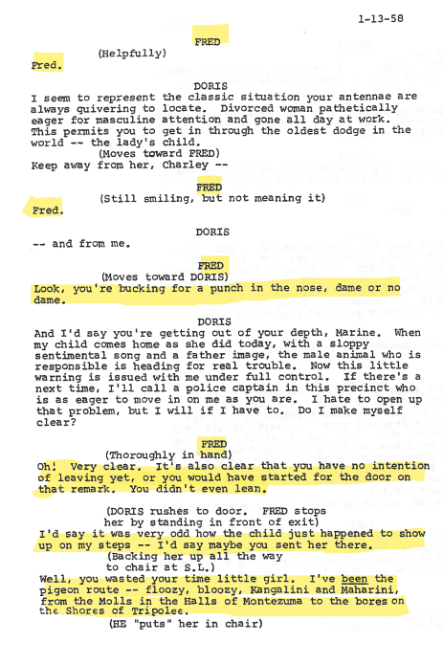
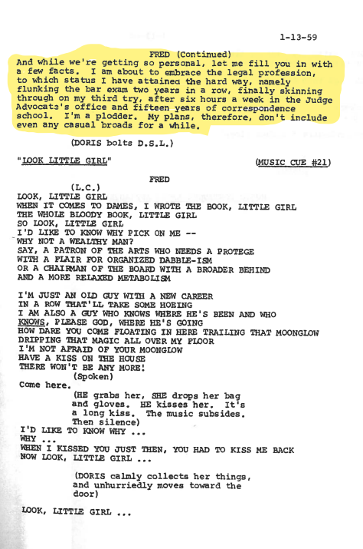
2-3-17 to 2-3-20
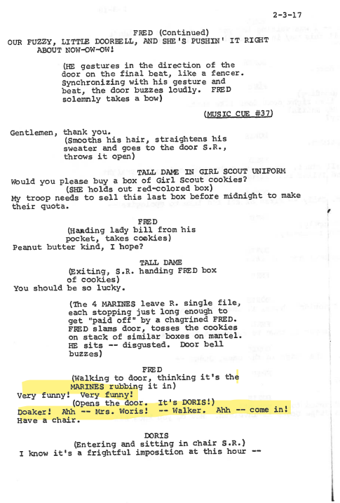
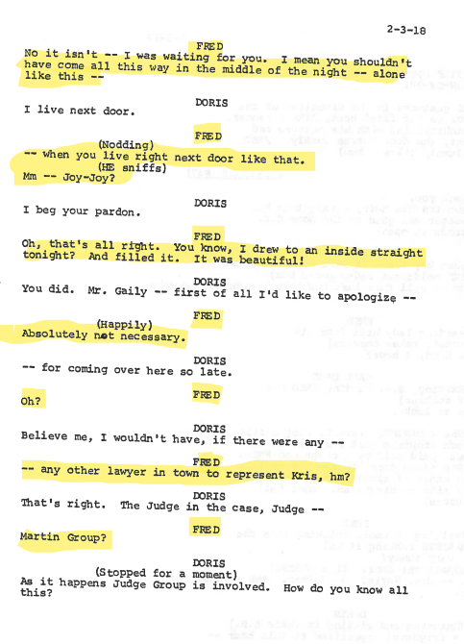
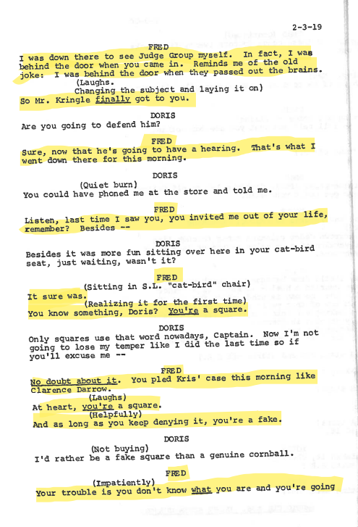
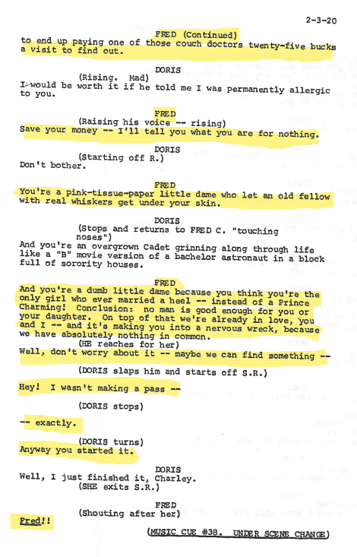
Songs

Please select and prepare one of the following songs. You may choose to use the backing track (or your own backing track), or sing acapella:

on the street where you live – my fair lady
original track: On The Street Where You Live - song and lyrics by Frederick Loewe, Bill Shirley, André Previn, The Warner Bros. Orchestra | Spotify
backing track: On The Street Where You Live (Karaoke Instrumental Track) [In the Style of Combo] - song and lyrics by ProSound Karaoke Band | Spotify

there is nothing like a dame – south pacific
original track: There Is Nothing Like A Dame - song and lyrics by South Pacific 1988 London Cast Recording Male Ensemble | Spotify
backing track: There Is Nothing Like a Dame (Karaoke Version from "South Pacific" ) - song and lyrics by Pop Music Workshop | Spotify

lullaby of broadway – 42nd street
original track: Lullaby of Broadway - song and lyrics by Jerry Orbach, 42nd Street Ensemble | Spotify
backing track: Lullaby of Broadway (from "42nd Street") - song and lyrics by Guy Dearden | Spotify

