R H Macy

1-12-47 to 1-12-50
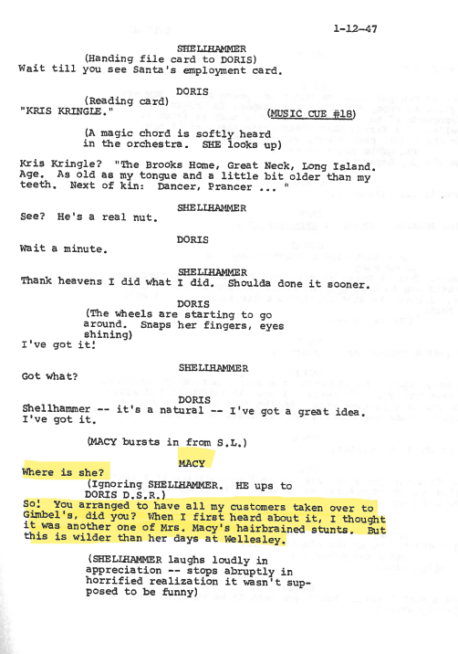
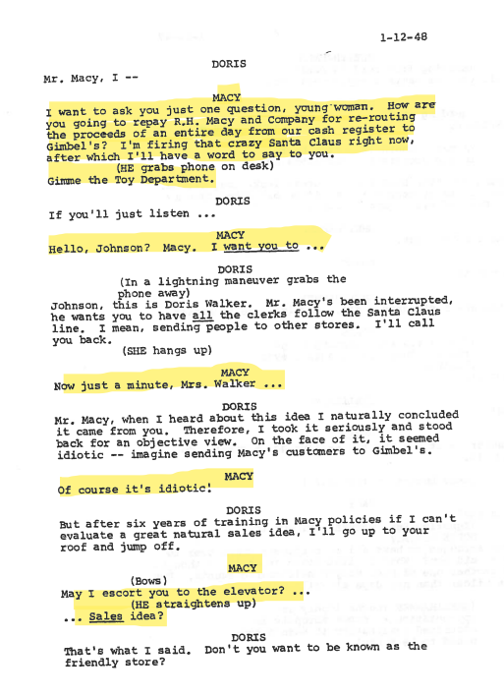
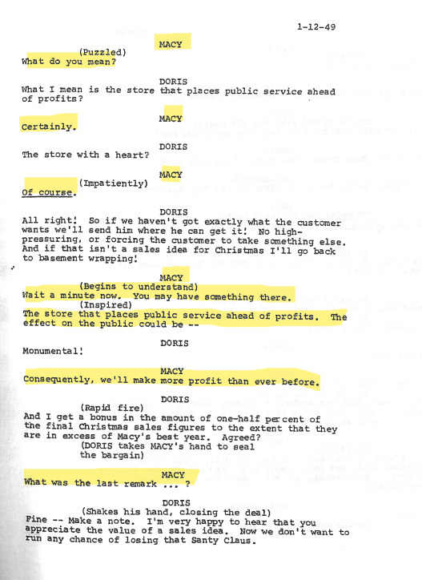
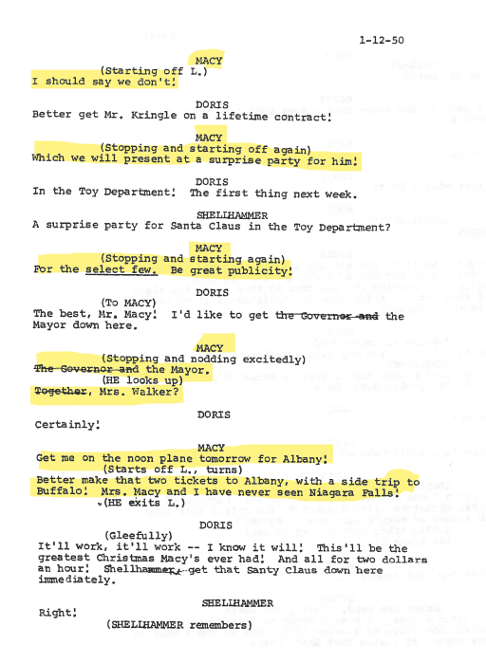
Songs

Please select and prepare one of the following songs. You may choose to use the backing track (or your own backing track), or sing acapella:

Oh, what a beautiful morning – Oklahoma
Original track: Oh, What A Beautiful Mornin' - From "Oklahoma!" Soundtrack - song and lyrics by Gordon Macrae, Darcy M. Proper | Spotify
Backing track: Oh, What a Beautiful Mornin' (Backing Track) - song and lyrics by David Keith Jones | Spotify

Seize the day – newsies
Original track: Seize The Day - song and lyrics by Ben Fankhauser, Jeremy Jordan, Newsies Original Broadway Cast | Spotify
backing track: Seize The Day (made popular by 'Newsies') [backing version] - song and lyrics by Party Tyme | Spotify

